Happy Easter!

Spring brings new beginnings and new opportunities.
Members, this is your opportunity to let your voice and ideas be heard at the National Convention at Daytona Beach in Florida. Bylaws and Administrative Procedures along with any form changes that you would like to propose are due to the National Headquarters no later than May 15, 2022. Visit our website https:\\nationalmcla.org to find the instructions and samples on how to submit the proposal. Please follow them.

May 1, 2021, thru April 30, 2022, is the period for our Units to use while filling out the Volunteer Reports. Please make sure to capture what every member does along with the good works your Units and Departments do. Before submitting them, please verify which National Committee Chairperson should receive the reports. You can find the list along with their addresses within this newsletter.
I had the honor and privilege to install the officers of the Morris Dixon and Spring Hill Units. It is always exciting to see new ladies step up into positions and take the roles as leaders. This shows the great mentoring that is happening out among our Units!
I also had the pleasure of attending the Southeast Division Conference as a guest of the PNP Norma A Liner Unit & the Southeast Division. The new Division Vice President Lynn Cortright and Asst. Becky Marcel did a wonderful job with their conference. It was exceptionally organized and fun!
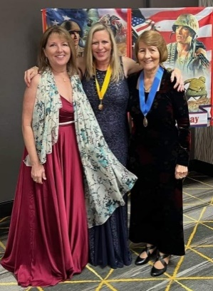
Finally, let us be ever mindful of the needs of our members and their families. Many hardships and losses have occurred and continue to happen beyond our control. Please keep them all in your prayers.
Semper Fidelis
Evelyn Joppa

Lynn Cortright, Becky Marcel & Eve Joppa
Southeast Banquet

Volunteer Reports are due to Committee Chairs by June 30th.

Send to the following:
Americanism:
Tracey Killinger, 1775 Molly Pitcher Hwy S, Chambersburg, PA 17202-9202
Child Welfare:
Pat Engel, 3888 Ricklyn Drive, Chambersburg, PA 17202-8673
Civics:
Judy Blackmer: 4530 Marquette Road, Chicago, IL 60629
Girl Scouts:
Mitzy Abeyta 446 Dennis St., Monte Vista, CO 81144-1179
Rehabilitation:
Viola Trevino, 3337 Casa De Amigos, Corpus Christi, TX 78411
VAVS:
Debby Kreuger 11824 Gray Court, Westminster, CO 80020-5991

